K L UNIVERSITY
FRESHMAN ENGINEERING DEPARTMENT

A Project Based Lab Report On

Assessment & performance Analytic system

SUBMITTED BY:
ID NUMBER NAME
2500040249 M.Bhargav
2500060005 Harsha Vardhan
2500060010 K.Bhanu kailash

UNDER THE ESTEEMED GUIDANCE OF Dr. Smitha kranthi ASSISTANT PROFESSOR



KL UNIVERSITY
Green fields, Vaddeswaram – 522 502 Guntur Dt., AP, India.

DEPARTMENT OF BASIC ENGINEERING SCIENCES



CERTIFICATE

This is to certify that the project based laboratory report entitled “Assessment & performance Analytic System ” submitted by M.Bhargav,K.Bhanu Kailash,Harsha Vardhan Varma bearing Regd. No. 2500040249 to the Department of COMPUTER SICENCE ENGINEERING , KL University in partial fulfillment of the requirements for the completion of a project based Laboratory in “Computational Thinking for Problem Solving (24SC1102)” course in I B Tech I Semester, is a Bonafede record of the work carried out by him/her under my supervision during the academic year 2025 – 2026.

PROJECT SUPERVISOR HEAD OF THE DEPARTMENT Dr. Smitha Dr. D. HARITHA

ACKNOWLEDGEMENTS

It is great pleasure for me to express my gratitude to our honorable President.

Sri. Koneru Satyanarayana, for giving the opportunity and platform with facilities in accomplishing the project-based laboratory report.
I express sincere gratitude to our Director Dr. A. Jagdeesh for his administration towards our academic growth.
I express sincere gratitude to our Coordinator and HOD-BES Dr. D. Haritha for her leadership and constant motivation provided in successful completion of our academic semester. I record it as my privilege to deeply thank you for providing us with the efficient faculty and facilities to make our ideas into reality.
I express my sincere thanks to our project supervisor Dr. Sireesha Gundu for her novel association of ideas, encouragement, appreciation, and intellectual zeal which motivated us to venture this project successfully.
Finally, we are pleased to acknowledge our indebtedness to all those who devoted themselves directly or indirectly to making this project a success.

Name: M.Bhargav
Name: K.Bhanu kailash
Name: Harsha Vardhan varma

ID No: 2500040249
ID No: 2500060005
ID No:2500060010

ABSTRACT

Analytical systems are fundamental tools used in engineering, scientific research, healthcare, and industrial applications for obtaining accurate and reliable data. The assessment of these systems is essential to ensure that the results produced are valid, consistent, and suitable for decision-making. Performance evaluation of an analytical system is carried out by examining several key parameters, including accuracy, precision, sensitivity, specificity, linearity, range, robustness, and reproducibility. Accuracy indicates how close the measured value is to the true value, while precision reflects the consistency of repeated measurements. Sensitivity determines the system’s ability to detect small changes in input, whereas specificity ensures that the system measures only the intended parameter without interference.
Furthermore, parameters such as limit of detection (LOD) and limit of quantification (LOQ) define the minimum levels at which analytes can be detected and quantified with acceptable reliability. The assessment process involves techniques such as calibration using standard references, validation procedures to confirm system suitability, and statistical analysis to evaluate variability and error. Errors in analytical systems are generally classified into systematic errors, which cause consistent deviations, and random errors, which arise due to unpredictable fluctuations.
A well-performing analytical system minimizes these errors and maintains stability under varying environmental and operational conditions. Proper assessment and continuous monitoring of performance are essential for ensuring quality control, enhancing reliability, and improving overall efficiency. These evaluations are particularly important in critical fields such as pharmaceuticals, environmental monitoring, and data analytics, where incorrect results can lead to significant consequences. Thus, the systematic assessment of analytical systems plays a vital role in achieving accurate, reproducible, and trustworthy outcomes.
Key Words: tickets, online, booking, website, movie.

INDEX

S.NO | TITLE | PAGE NO
1 | Introduction | 6
2 | Aim of the Project | 7
2.1 | Advantages & Disadvantages | 8
2.2 | Future Implementation | 8
3 | Software & Hardware Details | 9
4 | Data Flow Diagram | 10-11
5 | Algorithm for each module | 12
6 | Implementation | 13-15
7 | Integration and System Testing | 16-18
8 | Conclusion | 19

INTRODUCTION
Analytical systems are essential tools used to collect, process, and interpret data in various fields such as engineering, science, medicine, and industry. These systems help in making informed decisions by providing quantitative and qualitative information about a given sample or process. The reliability of any analytical result depends on the performance of the system used; therefore, proper assessment of analytical systems is highly important.
The assessment of an analytical system involves evaluating its ability to produce accurate, precise, and consistent results under different conditions. Various performance parameters such as accuracy, precision, sensitivity, specificity, linearity, and robustness are used to measure the effectiveness of the system. These parameters help in determining whether the system is suitable for its intended purpose and whether it meets the required standards.
In addition, analytical systems are subject to different types of errors, including systematic and random errors, which can affect the quality of results. To minimize these errors and ensure reliability, methods such as calibration, validation, and statistical analysis are employed. These techniques help in maintaining the efficiency and stability of the system over time.

- Easy to learn
- Structured language
- It produces efficient programs.
- It can handle low-level activities.
- It can be compiled on a variety of computers.

AIM
The aim of this study is to evaluate the performance of analytical systems by analyzing key parameters such as accuracy, precision, sensitivity, specificity, and reliability. It also aims to assess the effectiveness of methods like calibration and validation in ensuring consistent and error-free results. The study focuses on identifying sources of errors and improving the overall quality, efficiency, and dependability of analytical measurements for better decision-making in scientific and industrial applications.

The modules in this project are -
→To provide an any time any place service for the customer.
→To minimize the number of staff at the ticket box.
→To promote the film on the internet.
→To increase the profit.

ADVANTAGES
1. Improves Accuracy and Reliability
Ensures that the results obtained are correct and trustworthy, reducing the chances of wrong conclusions.
2. Enhances Quality Control
Helps maintain high standards in industries by continuously monitoring and evaluating system performance.
3. Reduces Errors
Identifies and minimizes systematic and random errors, leading to more consistent outcomes.
4. Supports Better Decision-Making
Provides reliable data that can be used for effective planning and problem-solving.
5. Increases Efficiency
Optimizes the performance of analytical systems, saving time and resources.
6. Ensures Consistency (Precision)
Produces repeatable results under the same conditions, improving confidence in measurements.
7. Validates System Performance
Confirms that the system meets required standards and is suitable for its intended purpose.

DISADVANTAGES
1. Time-Consuming Process
Evaluating performance through calibration, validation, and testing requires significant time.
2. High Cost
Involves expensive instruments, maintenance, skilled personnel, and standard reference materials.
3. Complex Procedures
Assessment methods and statistical analysis can be difficult to understand and implement, especially for beginners.
4.Requires Skilled Personnel
Proper evaluation and interpretation of results need trained and experienced professionals.
5. Possibility of Human Error
Mistakes during calibration, data entry, or analysis can affect the accuracy of results.
6. Dependence on Equipment Quality
Poor-quality instruments or improper maintenance can lead to incorrect performance assessment.
7. Environmental Influence
External factors like temperature, humidity, and noise can affect system performance and results.
8. Frequent Calibration Needed
Regular calibration is necessary to maintain accuracy, which increases workload and downtime.
9. Data Interpretation Challenges
Analyzing and interpreting large datasets can be complicated and may lead to incorrect conclusions if not handled properly.

FUTURE IMPLEMENTATION

The future implementation of analytical systems focuses on improving accuracy, speed, and automation by integrating advanced technologies. With the rapid development of artificial intelligence (AI) and machine learning (ML), analytical systems will become more intelligent, capable of self-learning, and able to predict errors before they occur. This will reduce human intervention and improve overall efficiency.

SYSTEM REQUIREMENTS

SOFTWARE REQUIREMENTS:
• Windows, Linux, or macOS
• Provides a platform for running analytical and statistical tools.
- Tools like Python, R, or MATLAB
- Used for statistical analysis, data processing, and modeling

HARDWARE REQUIREMENTS:

Processor: Minimum Intel i5 or higher
RAM: At least 8 GB (16 GB recommended for large data analysis)
Storage: 256 GB SSD or higher
Used for running analytical software and processing data

DATA FLOW DIAGRAM

Start

Input Data

Clean Data

Cabliration

Calculate Mean

Calculate Variance

Calculate Accuracy

Display Output

Decision

Stop

Step:1Start

ALGORITHM

Step-2: Initialize System
Set up the analytical instruments, software, and required parameters.
Step 3: Input Data Collection
Collect raw data from sensors, instruments, or datasets.
Step 4: Data Preprocessing
Remove noise and errors
Handle missing values
Normalize/standardize data
Step 5: Calibration
Calibrate the system using standard reference values to ensure accuracy.
Step 6: Perform Analysis
Process the data using analytical or statistical methods.
Step 7: Compute Performance Metrics
Evaluate key parameters:
- Accuracy
- Precision
- Sensitivity
- Specificity
- Linearity
Step 8: Error Analysis
Identify:
- Systematic errors
- Random errors
Step 9: Validation
Compare results with standard or expected values to verify correctness.
Step 10: Performance Evaluation
Check whether the system meets required standards.
Step 11: Output Results
Display or store results in the form of reports, graphs, or tables.
Step 12: Decision Making
- If performance is acceptable → Continue use
- If not → Recalibrate or improve system
Step 13: Stop
End the process.

IMPLEMENTATION

# Simple Analytical System Performance Evaluation

# Step 1: Input Data (sample values)

data = [10, 12, 11, 13, 12]

# Step 2: Preprocessing (remove noise - simple example)

clean_data = [x for x in data if x > 0]

# Step 3: Calibration (adjust values with a factor)

calibration_factor = 1.0

calibrated_data = [x * calibration_factor for x in clean_data]

# Step 4: Analysis (calculate mean)

mean = sum(calibrated_data) / len(calibrated_data)

# Step 5: Precision (calculate variance)

variance = sum((x - mean) ** 2 for x in calibrated_data) / len(calibrated_data)

# Step 6: Accuracy (compare with true value)

true_value = 12

accuracy = abs(mean - true_value)

# Step 7: Output Results

print("Clean Data:", clean_data)

print("Calibrated Data:", calibrated_data)

print("Mean:", mean)

print("Variance (Precision):", variance)

print("Accuracy Error:", accuracy)

# Step 8: Decision

if accuracy < 1:

print("System Performance: GOOD")

else:

print("System Performance: NEEDS IMPROVEMENT")

14

INTEGRATION AND SYSTEM TESTING
OUTPUTS

Screen Shots:

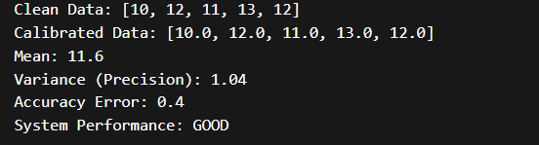

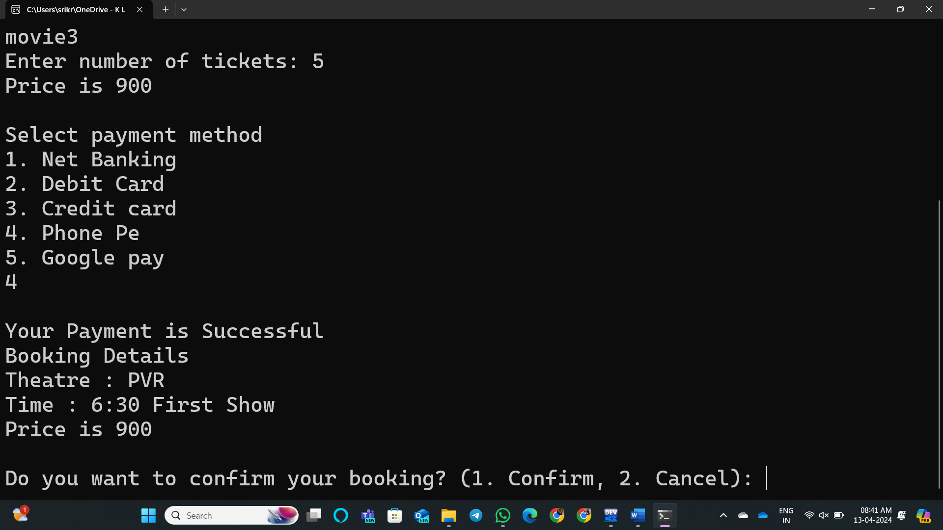

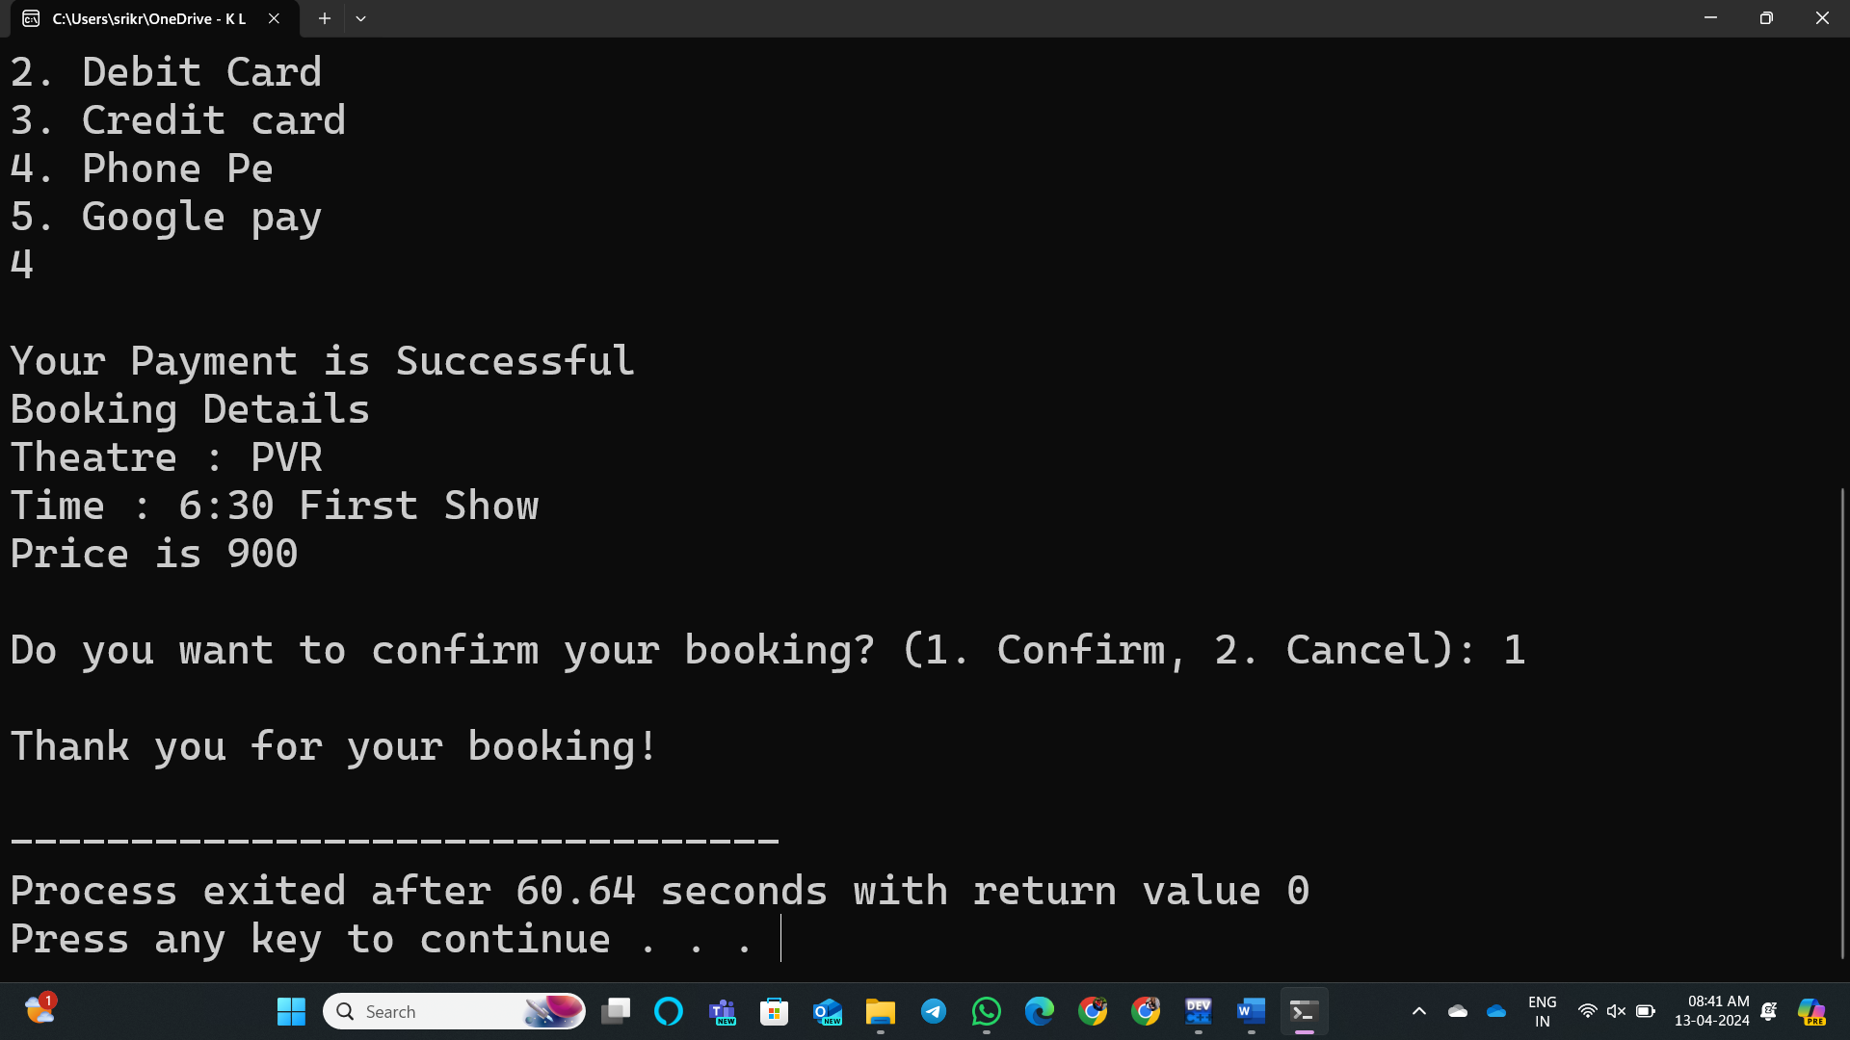

18

CONCLUSION

The assessment of analytical systems is essential to ensure the accuracy, precision, and reliability of results obtained from data analysis. By evaluating key performance parameters such as accuracy, precision, sensitivity, and robustness, it is possible to determine the effectiveness of a system and identify areas for improvement. Techniques like calibration, validation, and error analysis help in minimizing systematic and random errors, thereby enhancing overall system performance.

19

